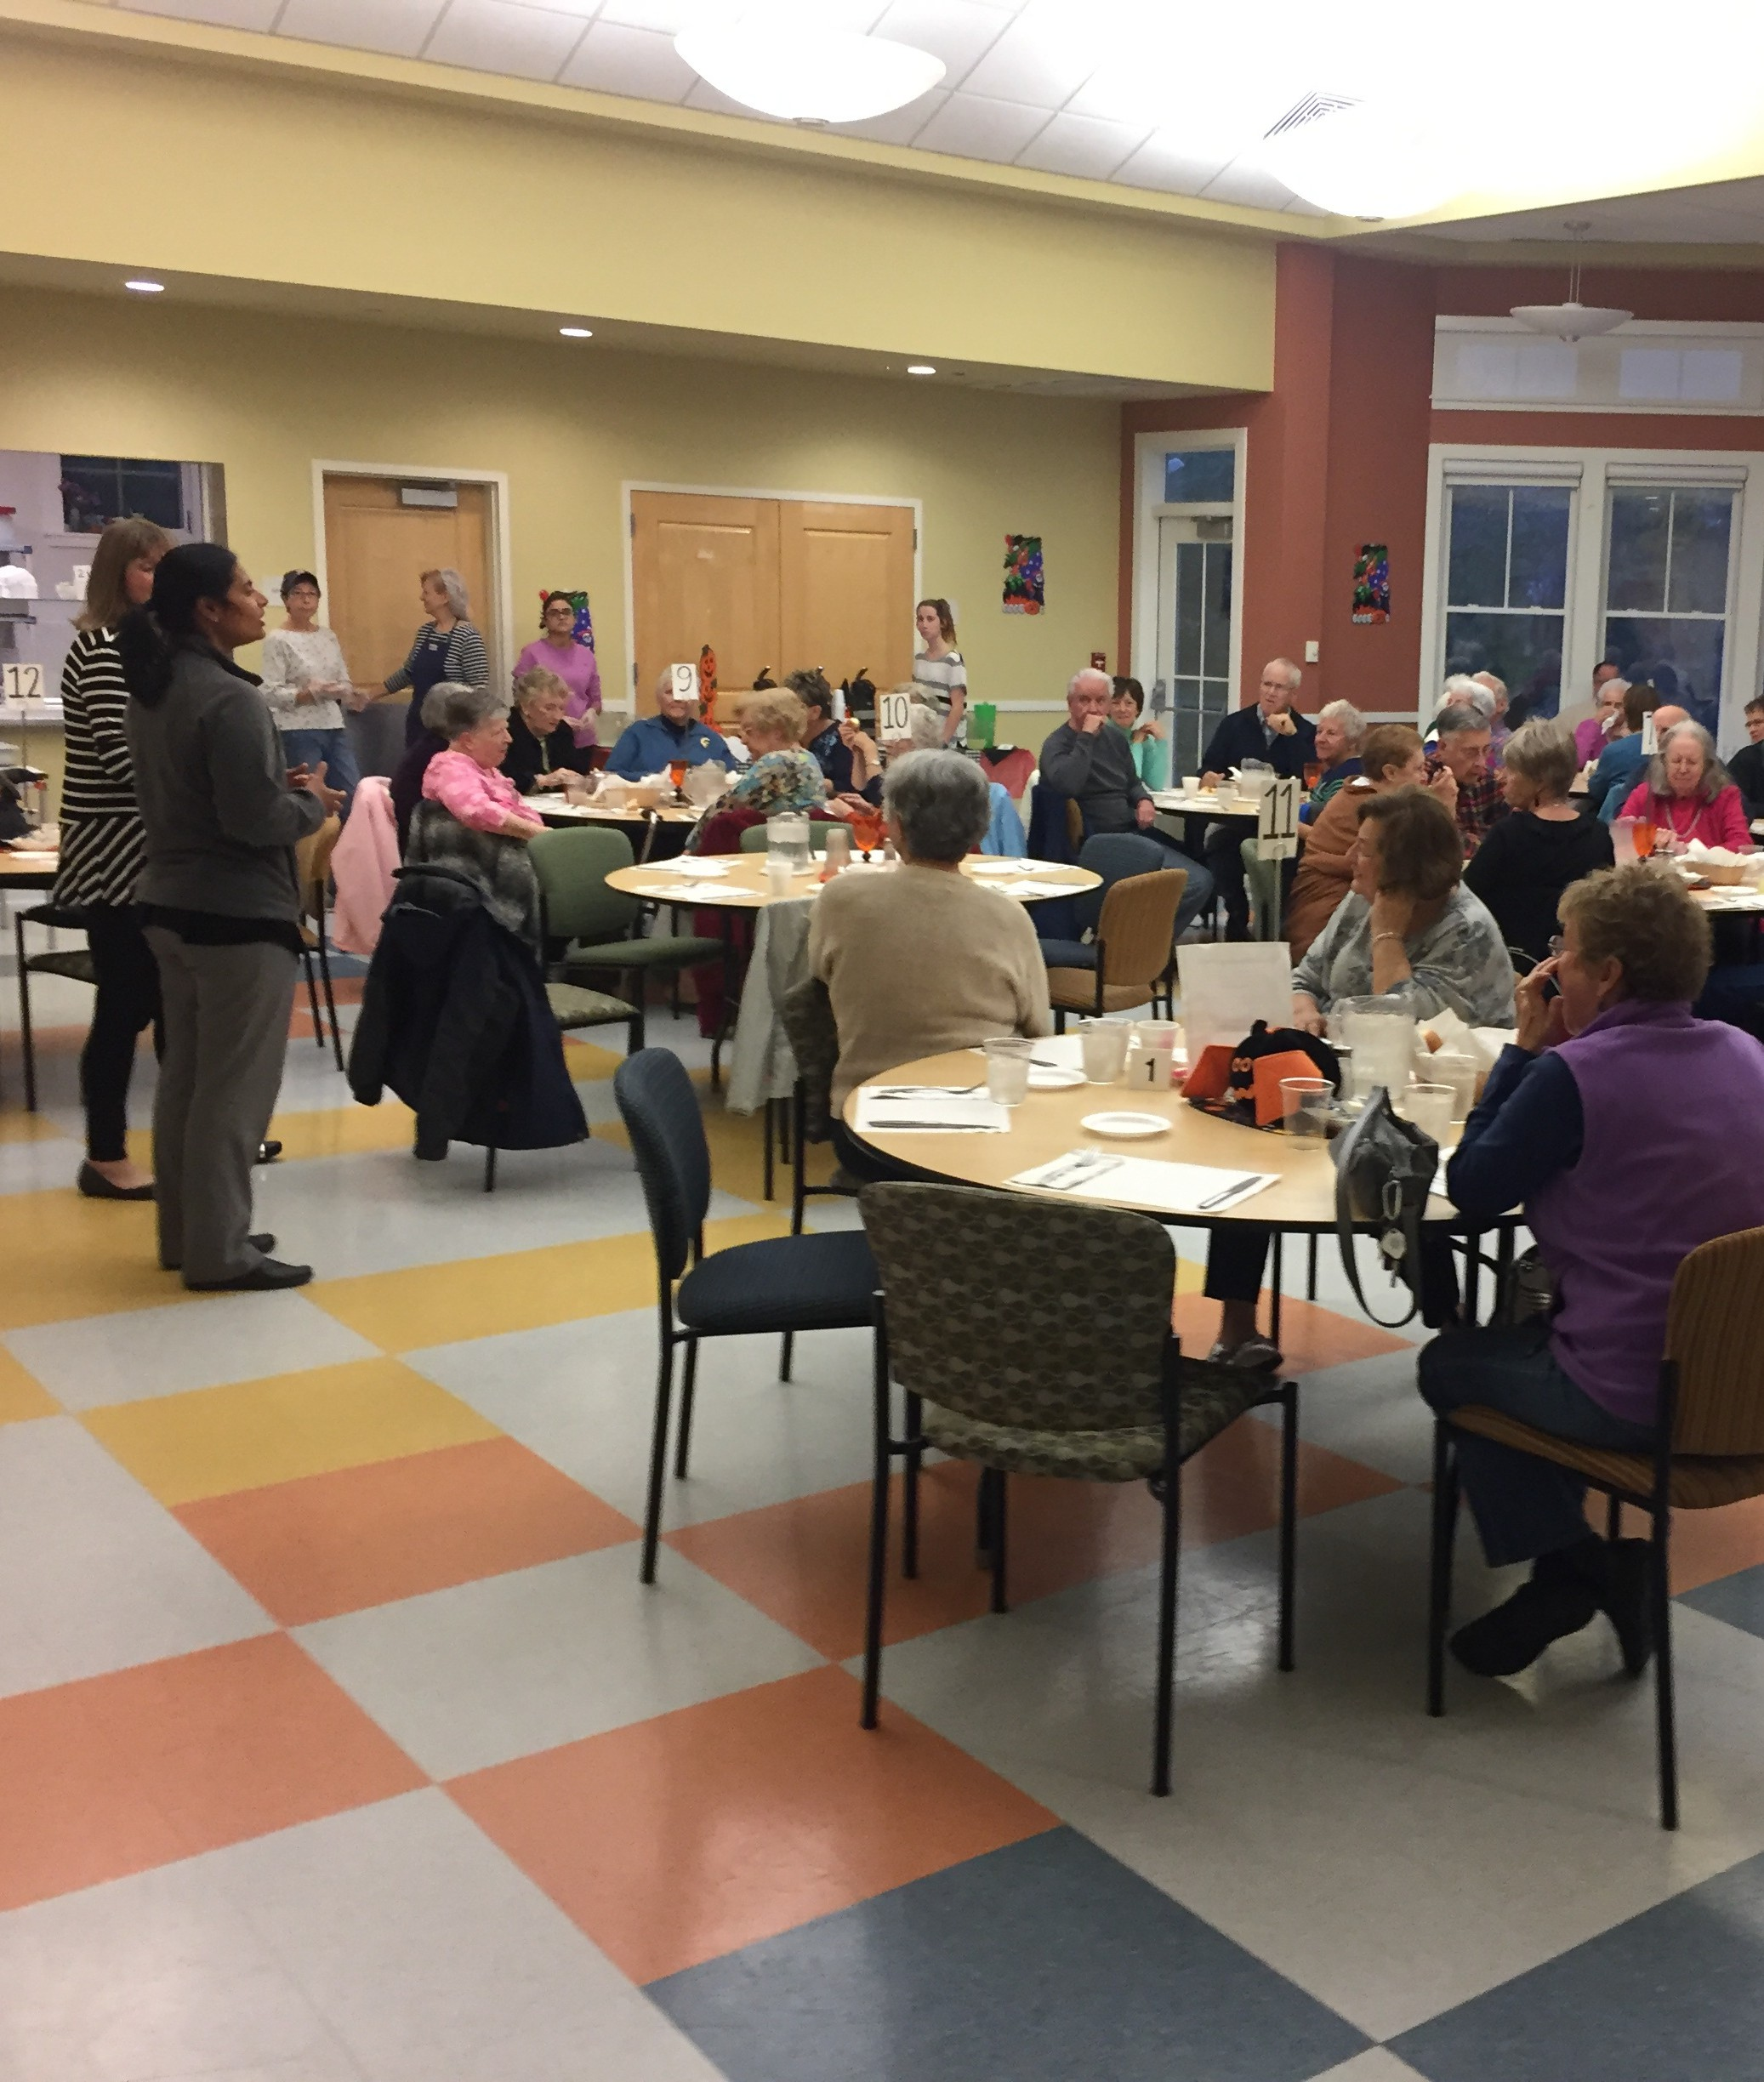
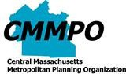
CENTRAL MASSACHUSETTS
FY
METROPOLITAN PLANNING ORGANIZATION

20
CMMPO 22

PUBLIC PARTICIPATION

PLAN

Document prepared by:
Staff of the Central Massachusetts Metropolitan Planning Organization 1 Mercantile Street, Suite 520, Worcester MA 01608

Prepared in cooperation with the Massachusetts Department of Transportation and the U.S. Department of Transportation - the Federal Highway Administration and the Federal Transit Administration. The views and opinions of the Central Massachusetts Metropolitan Planning Organization expressed herein do not necessarily reflect those of the Massachusetts Department of Transportation or the
U.S. Department of Transportation.

Notice

Notice of Nondiscrimination Rights and Protections to Beneficiaries Federal Title VI/Nondiscrimination Protections
The Central Massachusetts Metropolitan Planning Organization (CMMPO) hereby states its policy to operate its programs, services and activities in full compliance with federal nondiscrimination laws including Title VI of the Civil Rights Act of 1964 (Title VI), the Civil Rights Restoration Act of 1987, and related federal and state statutes and regulations. Title VI prohibits discrimination in federally assisted programs and requires that no person in the United States of America shall, on the grounds of race, color, or national origin, including limited English proficiency, be excluded from participation in, be denied the benefits of, or be otherwise subjected to discrimination under any program or activity receiving Federal assistance.

Related federal nondiscrimination laws administered by the Federal Highway Administration, the Federal Transit Administration, or both prohibit discrimination on the basis of age, sex, and disability. These protected categories are contemplated within the CMMPO’s Title VI Programs consistent with federal and state interpretation and administration. Additionally, the CMMPO provides meaningful access to its programs, services, and activities to individuals with limited English proficiency, in compliance with US Department of Transportation policy and guidance on federal Executive Order 13166.

State Nondiscrimination Protections

The CMMPO also complies with the Massachusetts Public Accommodation Law, M.G.L. c272 §§ 92a, 98, 98a, prohibiting making any distinction, discrimination, or restriction in admission to or treatment in a place of public accommodation based on race, color, religious creed, national origin, sex, sexual orientation, disability or ancestry. Likewise, CMMPO complies with the Governor’s Executive Order 526, section 4, requiring all programs, activities and services provided, performed, licensed, chartered, funded, regulated, or contracted for by the state shall be conducted without unlawful discrimination based on race, color, age, gender, ethnicity, sexual orientation, gender identity or expression, religion, creed, ancestry, national origin, disability, veteran’s status (including Vietnam-era veterans), or background.

ADA / 504 Notice of Nondiscrimination

The CMMPO does not discriminate on the basis of disability in admission to its programs, services, or activities; in access to them; in treatment of individuals with disabilities; or in any aspect of their operations. The CMMPO also does not discriminate on the basis of disability in its hiring or employment practices.

This notice is provided as required by Title II of the American with Disabilities Act of 1990 (ADA) and Section 504 of the Rehabilitation Act of 1973.

Translation
English: If this information is needed in another language, please contact the CMRPC/CMMPO Title VI Specialist at (508) 756-7717.

Spanish: Si necesita esta información en otro lenguaje, favor contactar al especialista de Título VI de CMRPC/CMMPO al (508) 756-7717.

French: Si vous avez besoin d'obtenir une copie de la présente dans une autre langue, veuillez contacter le spécialiste du Titre VI de CMRPC/CMMPO en composant le (508) 756- 7717.

Portuguese: Caso esta informação seja necessária em outro idioma, favor contatar o Especialista em Título VI do CMRPC/CMMPO pelo fone (508) 756-7717.

Vietnamese: Nếu bạn cần thông tin bằng ngôn ngữ khác, xin vui lòng liên lạc với Tiêu đề VI Chuyên CMRPC/CMMPO tại (508) 756-7717.

Chinese: 如果⽤另⼀种语⾔需要的信息，请联系第六章专⻔CMRPC/CMMPO（508）756- 7717。

This document is available from the CMMPO in large print, on audio tape, and Braille upon request.

Complaints

Filing a Complaint

Individuals who feel they have been discriminated against in violation of Title VI or related Federal nondiscrimination laws, must file a complaint within 180 days of the alleged discriminatory conduct to:

Ms. Janet Pierce, Executive Director
Central Massachusetts Regional Planning Commission 1 Mercantile Street, Suite 520
Worcester, MA 01608
(508) 756-7717

To file a complaint alleging violation of the State’s Public Accommodation Law, contact the Massachusetts Commission Against Discrimination within 300 days of the alleged discriminatory conduct at:

Massachusetts Commission Against Discrimination (MCAD) One Ashburton Place, 6th floor
Boston, MA 02109
(617) 994-6000
TTY: (617) 994-6196

Questions, complaints, or requests for additional information regarding ADA and Section 504 may be forwarded to:

Ms. Janet Pierce, Executive Director
Central Massachusetts Regional Planning Commission 1 Mercantile Street, Suite 520
Worcester, MA 01608
(508) 756-7717

Endorsement Sheet

Central Massachusetts Metropolitan Planning Organization Endorsement Sheet
FY 2022 Program Year Public Participation Plan (PPP)

The Central Massachusetts Metropolitan Planning Organization (CMMPO) hereby endorses the 2022 Program Year Public Participation Plan (PPP) document. The PPP ensures early and continuing opportunities for the public to express their views on transportation issues and to become active participants in the transportation decision-making process of the CMMPO. The 2022 Program Year PPP document was endorsed at a meeting of the CMMPO on Wednesday, December 15, 2021.

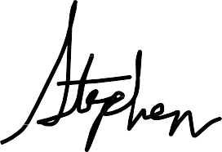
Jamey Tesler, Secretary and Chief Executive Officer Massachusetts Department of Transportation Chair, Central Massachusetts MPO

Table of Contents

Purpose 01
Background 03
Values and Principles 05
Goals 06
Tools 08
Methods 15
Accessibility 21
Planning Documents 26
Performance Measures 30

Purpose
The Central Massachusetts Metropolitan Planning Organization (CMMPO) is responsible for carrying out the continuing, cooperative, and comprehensive transportation planning process in the Central Massachusetts region that results in plans and programs that consider all transportation modes and supports metropolitan community development and social goals.

The CMMPO planning region is comprised of 40 communities, including the City of Worcester and 39 towns. The planning region is divided in 6 sub-regions (as shown on the map below). The CMMPO staff is also the Central Massachusetts Regional Planning Commission (CMRPC) transportation staff, and works on behalf of the CMMPO
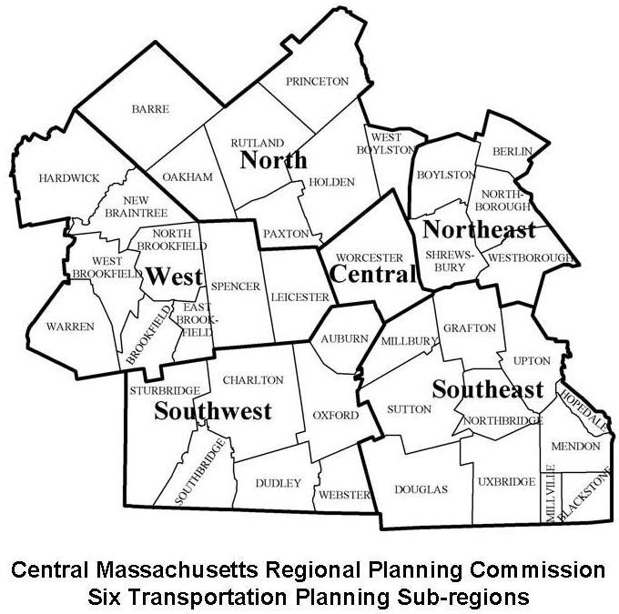

Continued

The purpose of this Public Participation Plan (PPP) is to ensure early and continuing access and opportunities for the public to express their views, and critiques on transportation projects as well as promote active participation throughout the transportation decision- making process. In addition, this plan is designed to function as a guide for all CMMPO public participation planning activities.

Accordingly, this PPP has been developed with input from a wide variety of transportation stakeholders, including those interested in environmental, freight, transit, roadway, pedestrian, and bike concerns. Input on ways to improve outreach, communication, and feedback on transportation planning issues has been, and will continue to be, an on-going process. Valuable input that has been incorporated into this plan includes:

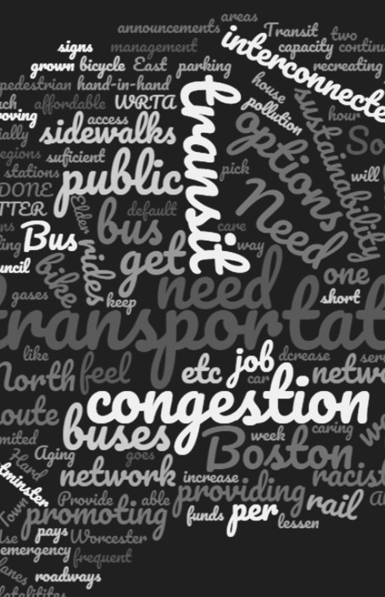
Maintain - on-going dialogue with stakeholders so that information about transportation projects and planning activities (research studies, data analysis, etc.) is provided early in the planning process when design recommendations and potential mitigation can be addressed most efficiently.

Incorporate - stakeholder data and recommendations into the planning process at early stages of project development.

Communicate - in easy to understand formats using visualizations to explain technical information while meeting accessibility requirements, including translations in languages other than English.

Provide - meaningful, accessible and transparent information to all stakeholders, including information about benefits and burdens related to transportation projects.

Background

Title 23 Code of Federal Regulations Part 450 requires all metropolitan planning agencies to develop a Public Participation Plan "in consultation with all interested parties." Key requirements of the public participation process are: an all-inclusive decision-making process and a proactive public involvement process that provide timely public notice, complete information, full access to decision-making and support early consultation in the development of metropolitan transportation plans and transportation improvement programs.

Relevant pieces of legislation applicable to the CMMPO public participation process

Infrastructure Investment and Jobs Act (2021)

Executive Order 13985 - Racial Equity (2021)
Current transportation enabling regulation
Emphasizes the importance of public involvement of all sectors and users of the transportation network in the transportation planning process.

Advances racial equity and support for marginalized and underserved communities by allocating resources to advance fairness and opportunity by promoting equitable delivery of government benefits and opportunities, including advancing meaningful engagement with all communities.

US DOT Order 1000.12C (2021)
Requires that "applicants and recipients are adequately informed about how programs or activities will potentially impact affected communities, and to ensure that diverse views are heard and considered throughout all stages of the consultation, planning, and decision-making process."

FTA Circular 4702.1B (2012)
The Circular recommends "to seek out and consider the needs and input of the general public, including interested parties and those traditionally underserved by existing transportation systems, such as minority and Limited English Proficient (LEP) persons, who may face challenges accessing employment and other services."

Continued

Executive Order 13166 - Limited English Proficiency (2000)
Requires that federal agencies publish guidance to clarify LEP obligations for their recipients.
Prohibits conduct that has a disproportionate effect on LEP persons, meaning different treatment based upon an individual's inability to speak, read, write or understand English as it may constitute a type of national origin discrimination.

Executive Order 12898 - Environmental Justice (1994)
Emphasizes in the fair treatment and meaningful involvement of all people regardless of race, color, national origin, or income with respect to the development, implementation and enforcement of environmental laws, regulations and policies.
Directed federal agencies to develop environmental justice strategies to help address disproportionately high and adverse human health or environmental effects of their programs on marginalized minorities and low income populations.

American with Disabilities Act of 1990 (ADA)

Title VI of the Civil Rights Act of 1964
States that "no qualified individual with a disability shall, by no reason of such disability, be excluded from participation in or be denied the benefits of services, programs or activities of a public entity."
Locations for public participation and the information provided must be accessible to persons with disabilities.

States that "no person in the United States shall, on the grounds of race, color, or national origin, be excluded from participation in, be denied the benefits of, or be subject to discrimination under any program or activity receiving federal financial assistance."

Values and Principles

The Central Massachusetts Metropolitan Planning Organization (CMMPO) public participation core values are included in the CMMPO Memorandum of Understanding (May 2021) as follows:

"The members of the CMMPO recognize that transportation planning and programming must be conducted as an integral part of and consistent with the regional planning and development process, and that the process must involve the fullest possible participation by state agencies, local governments, private institutions, other appropriate groups and the general public."

Moreover, the CMMPO recognizes the importance to operate in concert with MassDOT's values, goals and principles. As such, the CMMPO public participation principles are:

Promote respect
Provide proactive and timely opportunities for involvement Offer authentic and meaningful participation
Provide a clear, focused and predictable process Foster diversity and inclusiveness
Be responsive to participants
Record, share and respond to public comments Self-evaluation and plan modification

Goals The CMMPO recognizes the importance of a robust public involvement process. The goals included in

Meaningful Public Engagement
this section reflect the CMMPO values and principles, and are geared towards achieving meaningful public engagement in the transportation planning process.

Increase diversity

Identify, engage and elevate new voices
Those who are encouraged to participate in public engagement processes should represent, as appropriate to a project or those impacted, a range of socioeconomic, ethnic, and cultural perspectives and include people from low- income and minority neighborhoods, people with limited English proficiency, and other traditionally underserved / underrepresented populations.

Ensure accessibility

Staple in all that we do
Every effort should be made to ensure that participation opportunities are physically, geographically, temporally, linguistically and culturally accessible. That applies to all the communications, materials and locations.

Provide relevance

Work in pending issues and needs first
Issues should be framed clearly and simply such that the significance and potential effect may be understood by the greatest number of participants.

Foster participant satisfaction

Participants are co-creators in the process
The CMMPO should encourage the public to participate in project and initiative-related discussions, recognizing that people who take the time to participate feel it is worth the effort to join the discussion and provide feedback. Moreover, focused outreach efforts should be made to those affected or potentially affected by the transportation planning process.

Clearly define potential for influence
Provide ample opportunities to access the decision-making process The CMMPO process should clearly identify and communicate where and how participants can have influence and direct impact on the decision- making process.

Establish and maintain partnerships

Multiple issues are related to transportation, therefore, multiple partners need to be part of the solution
The CMMPO develops and maintains partnerships with communities, community-based organizations, and key stakeholders through diverse methods. It strives to communicate regularly and develop trust with communities and all our partners, while helping build community capacity as it relates to transportation planning.

Assess, adapt and report

Provide multiple mechanisms for evaluation and document the process and outcomes
At a minimum, the CMMPO should record all engagement activities performed and the comments of the participants. The evaluation of the CMMPO engagement efforts should assess the methods used to engage with diverse communities, how the comments and perspectives were incorporated into the decision-making process and what were the results of such efforts. Every major planning document should include a report with a summary of the public outreach activities, an assessment of the tools and methods used, performance measures and lessons learned.

Tools

CMMPO's
Proven Tools

Information

Throughout the years the CMMPO has been consistently engaging with the region's stakeholders in the transportation planning and decision-making process. Nevertheless, the CMMPO is always seeking to expand the set of tools used for public outreach and engagement. The COVID-19 pandemic presented several challenges, and as a result, new tools were tested and incorporated in the decision- making process. The CMMPO uses three types of tools:
1) to relay information, 2) to promote the planning process, and, 3) to engage with the public. A summary is included below.

It is always important to provide information about the CMMPO's planning activities. Although the CMMPO has previously made major efforts to engage with stakeholders and hard to reach populations, there is always a segment of the public that need the basic information to understand the transportation planning process, as well as to understand why their participation in the process is important. It is a key piece in the overall capacity building of the CMMPO stakeholders. Some of the Information tools used by the CMMPO are:
Website
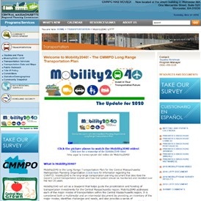
The CMMPO uses the CMRPC's website as the major outlet for information, www.cmrpc.org. The website has the major links to the transportation division, a direct link to the Mobility2040: The Update for 2020, as well as links to other transportation planning documents. As a result of the COVID-19 pandemic, a new webpage with access to the "CMMPO On-Demand" was created. Here members of the public can find the recordings of the CMMPO meetings, meetings agendas and minutes.

YouTube Videos
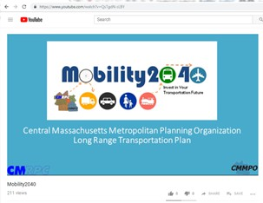
The CMMPO has a number of videos available in YouTube as a tool to explain how the CMMPO works, its role and responsibilities. Among the library of videos available, some portray aspects of the daily work of the transportation staff collecting data in the field, while other videos are instructional or "how-to-videos". Most recently, videos from the CMMPO meetings and the CMMPO Advisory Committee meetings are available in the "CMMPO On-Demand" webpage.

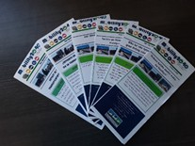
Brochures
Brochures are designed to disseminate information at events and also as a starter of one-on-one conversations. Some available brochures include "Say Hello to the MPO", "CMMPO Title VI Program", "CMAQ Project Funding", among others.

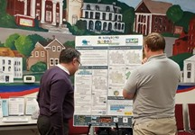
Posters
Posters and large formats allow for the display of maps and data in a more accessible way to participants at events or Open Houses. Posters are usually used as an ice-breaker at meetings to spark one-on-one conversations with attendees.

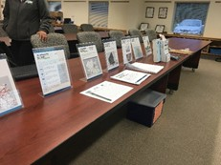
Table Displays
Similar to the posters, the table displays are considered useful as "conversations starters". Each display can portray a specific topic, project or idea. This tool provides an opportunity for people interested in a particular topic to ask questions and comment.

Promotion

The promotion of the planning process requires multiple points of communication. Community bulletin boards, flyers, social media, cable access TV, major circulation newspapers as well as regional events or activities are among the tools used by the CMMPO to promote the opportunities to participate in the planning process and to provide comments. These tools can also be used to announce subregional meetings and to promote surveys. Some of the Promotion tools used by the CMMPO are:
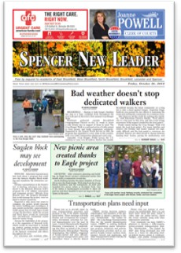
Press Releases and Public Notices
Press releases and public notices are developed and sent to the region's media contacts. Typically, a press release includes a list of meetings, times and locations, contact information, website addresses and links to online surveys. Some of the regional newspapers that the CMMPO traditionally uses are: Spencer New Leader, Sturbridge Villager, Webster Times, Charlton Villager, Blackstone Enlightener. The press releases are also translated into Spanish and sent to El Vocero Hispano, the region’s major Hispanic newspaper.

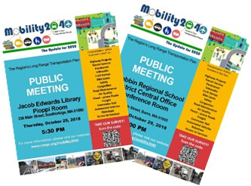
Flyers
Flyers are used to promote events, workshops and meetings. The flyers are mailed, posted at meeting places, shared on Facebook and sent by email to interested parties within the region. Flyers are particularly useful in high traffic locations, public libraries and senior centers.

Emails
Email blasts are used as a tool to announce the start of a major planning outreach process, promote online surveys and to promote events, meetings and workshops. The CMMPO uses the ConstantContact platform to send emails to previously formatted lists, including the CMMPO members, Advisory Committee members, town planners, planning board members, select board members, town administrators and town clerks, CMRPC Transportation Committee members, commissioners, town engineers, chambers of commerce, legislators and contacts from environmental organizations.

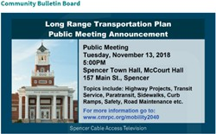
Community Bulletins and Cable Access TV
When information is sent to the CMMPO communities, more than often it is displayed in the community's online bulletin board. Announcements through Cable Access TV, where available, are often used as an offline alternative.

E-Newsletter
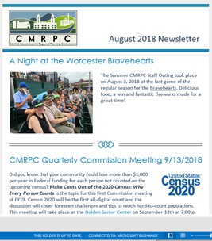
Many organizations use newsletters to keep their client base informed. CMRPC has a monthly newsletter that reaches hundreds of email contacts via ConstantContact. The CMMPO staff provides monthly articles related to all transportation activities on behalf of the CMMPO.

Other organizations, like the Blackstone Valley Chamber of Commerce, the Worcester Regional Chamber of Commerce, the Coalition for a Greater Healthy Worcester County and the 495 Metrowest Partnership have shared CMMPO outreach-related information in their newsletters.

Social Media
CMRPC has a strong presence in social media, with a base of thousands of followers in both Twitter, Facebook, LinkedIn and Instagram. Each social media platform reaches to a different audience. The CMMPO staff regularly submit transportation-related content and post in CMRPC's approved social media platforms. Social media is used as a tool to share information, promote events and also as an opportunity to engage with the public. it also provides a direct connection with CMRPC's website and the CMMPO's webpage, which is the main hub of information. Hootsuite enables staff to better manage, schedule, and track information being shared across multiple social media platforms. Another valuable tool is ArchiveSocial. It provides archiving capabilities of all the social media posts and interactions with the public.

A Content Planning Calendar is often used by the CMMPO in major outreach efforts. The calendar includes the contents, hashtags, images and links that are going to be used in each of the social media posts.

Further, paid social media advertisements allow staff to target a specific audience to meet established demographic criteria. These ads – although at a substantive additional cost – can boost participation among the desired audience and engage certain populations who could otherwise be left out.

CMRPC implemented a Social Media Policy to guarantee a safe space for public interaction, including moderation and response to comments. The CMRPC's Social Media Policy can be found in the agency's Facebook page. Analytics are compiled for every major outreach effort perform for planning documents, like the Long-Range Transportation Plan (LRTP) and the Transportation Improvement Program (TIP), topical campaigns (i.e. Bike Month promotion), or research studies and surveys, as each relates to the overall performance of the CMMPO outreach activities.

Online Engagement Tools

The COVID-19 pandemic accelerated the adoption of online engagement tools. Most of these tools are highly interactive and are available at no cost, while others are part of a subscription package. Another positive aspect of these tools is that their capabilities allow for a better understanding of how data is used to inform decisions, potential tradeoffs, as well as quick visualizations. Some of the Online Engagement tools used by the CMMPO are:
Dashboards
As part of the numerous mapping tools available under the ESRI licensing agreement, the CMMPO staff uses dashboards as a visualization tool to support the planning and decision-making process. Dashboards are a new online interactive and intuitive tool that can be used by the public to access georeferenced data, maps and other information related to a project or a plan. It is a visual way to offer participants a comprehensive overview of how data-driven decisions are made. The CMMPO currently maintains several dashboards that are available as a clearinghouse of information, a way to share information prior to a public meeting, among other applications.

Whiteboards
Online whiteboards, such as Google Jamboard, are an easy to use application where participants can write "post-it" notes virtually. It works well during online meetings as it is shared live with all the participants. With Google Jamboard, multiple slides can be prepared in advance allowing participants to toggle the slides and work on their own. Also, a link to a specific whiteboard can be shared in social media to gather input either before or after a meeting. It is a great tool for brainstorming, visioning exercises, or to gather general input about a particular topic.

Visualizations
CMMPO staff uses StreetMix as a free visualization tool available online to quickly show how a Complete Streets approach could potentially look like for a particular roadway segment. Members of the public can add their aspects and ideas to any given streetscape. It is an easy and intuitive tool that quickly captures the essence of the likely benefits of a Complete Streets project.

Surveys
Online surveys are a way to gather information from the general public concerning a wide array of topics. Currently, the CMMPO staff uses SurveyMonkey as the preferred survey tool. It allows for integration with multiple online platforms, produces basic dashboards related to survey responses, and provides easy to download graphs and charts portraying the survey results. Surveys are carefully crafted. Typically, technical jargon is minimized or removed from the questions to increase accessibility to the general public. The surveys can be shared in social media, either with a QR code format or printed and distributed at in-person events. Other survey platforms used by the CMMPO are Survey 123 from ArcGIS, mostly used for data collection, and Typeform, an online survey builder that incorporates graphic elements.

Online Polling
Free polling services are also used during online meetings. The most commonly tool used is Poll Everywhere. With this application, participants can submit a text message with answers to questions. The responses are shared live during the meeting.
Word Clouds
Word clouds are an easy way to share in a live meeting what the attendees are thinking. It can be a response to a survey question, ideas and commentary, among other uses. The higher the frequency of a given word, the larger its text size in relation to other provided comments. There are many free word cloud builders available online. Most of these tools provide the option of a downloadable Excel file or PDF file with the words included in the cloud.
Mobile Applications
The CMMPO looks forward to exploring and using mobile applications. Currently, MassDOT is developing a mobile public engagement application that could potentially enhance the public's participation and involvement in the development of the region's the Long-Range Transportation Plan (LRTP) and the Transportation Improvement Program (TIP).

Methods

CMMPO's Proven Methods for Public Engagement

Committees

There are several methods for engagement that are regularly used by the CMMPO to actively include the planning region's stakeholders, including those that are traditionally underrepresented in the transportation planning process. These methods are included in this section. The COVID-19 pandemic presented both challenges and opportunities to test new engagement methods with the public.

There are many ways in which the public can be part of the decision-making process. Participating on committees often provides a direct and meaningful engagement experience. Some of the Committees that support the CMMPO are:
Central Massachusetts MPO Advisory Committee
The CMMPO Advisory Committee performs in an advisory capacity and provides commentary and recommendations on documents requiring the CMMPO endorsement. Recommendations made by the Committee are presented by the CMMPO staff to the CMMPO. The CMMPO Advisory Committee meets once a month. All meeting notices and agendas are posted online. Meeting recordings are available online as well. The CMMPO Advisory Committee Chair is an Ex-Officio member of the CMMPO. The CMMPO Advisory Committee recently updated its Bylaws. The document includes information about the membership, the election process, roles and responsibilities, and other committee-related protocols.
Transportation Planning Advisory Group (TPAG)
This group acts in an advisory capacity to the Worcester Regional Transit Authority (WRTA). The TPAG provides a forum for addressing service-related issues that impact the WRTA’s elderly and disabled transit users. Representation on the TPAG is broadly based, including elderly and disabled service users, human service agencies, the WRTA’s service providers, the WRTA Administrator as well as representatives from the CMMPO staff. Its regular monthly meetings are held the third Wednesday at the WRTA Hub's Conference Room. The meetings are advertised and open to all who wish to attend.

Corridor Profile Study Technical Task Force
Technical Task Forces are established when deemed necessary for Corridor Profile Studies (CPS) conducted by the CMMPO staff. The purpose of these task forces is to provide early input on transportation issues affecting a particular corridor, to review work completed by staff and to provide recommendations as to which suggested improvement options, if any, should proceed toward project development. The membership of such technical task forces varies but generally includes key local officials from each of the host communities, and as needed, technical, legislative and MassDOT. The meetings are generally held monthly during the study process. The meetings are advertised and open to all who wish to attend.

Other CMMPO-related Technical Task Forces
These groups are formed on an as-needed basis. Most of the time is by invitation only. The purpose of these task forces or modal steering committees is to provide early input on issues related to a particular subject, to review work completed by staff or hired consultants, and to provide advisory recommendations on potential courses of action. Membership on these task forces varies but is generally made up of those with technical expertise on a particular subject.

Non-CMMPO Committees and Workgroups
The CMMPO staff actively participates in many committees and workgroups. Through the ongoing partnerships, staff has the opportunity to engage with committee members in topics related to transportation planning. Some of the Committees and workgroups where staff actively participate are the City of Worcester Transportation Advisory Group, Healthy Aging Designation Committee, the Community Health Improvement Plan (CHIP) Policy Committee, the Rural Regional Caucus, and others.

In-person meetings

In-person meetings have been used as a traditional method for engagement with the public. The CMMPO meets regularly on the third Wednesday of each month at 4:00 PM. The meetings are open to the public. The Advisory Committee meets on a monthly basis as well, on the fourth Wednesday at 3:00 PM. Meeting notices and agendas are posted on the website. The CMMPO staff also meets regularly with a diverse array of stakeholders throughout the region, the Worcester Urbanized Area, officials from state's agencies, and bordering MPO's in topics related to transportation planning.

As part of the process to conduct an in-person meeting, the CMMPO needs to provide adequate and timely public notice about the meeting. Further, the meetings need to be held at accessible locations and convenient times. It is recommended to arrange meetings with the public or targeted population at places where they already congregate, including senior centers, English as a Second Language classes and neighborhood meetings, to mention a few.

Virtual meetings

As a direct result of the COVID-19 pandemic, virtual meeting formats were added as accepted new methods for engagement with the CMMPO. The virtual meetings have been determined to be a convenient option for public participation. To ensure the continuity of operations, the CMMPO have utilized tools such as ZOOM, GoToMeeting, and Microsoft TEAMS, in order to conduct meetings virtually.

The online meeting platform Zoom offers both a “meeting” and a “webinar” option. The meeting option provides for excellent two-way communication opportunities as it allows attendees to unmute themselves and participate. The webinar option gives the presenters or panelist full control over the event. This method is best used to share information and receive feedback. Similar to a regular in-person meeting, virtual meetings require careful planning and preparation in advance. This includes developing presentation materials and handouts, and prepare virtual engagement tools, like polls and/or dashboards if needed. It also requires prior technical testing to determine that all video and audio functions are working correctly.

Hybrid meetings

Hybrid meetings can be defined as a in-person meeting with the opportunity for some participants to participate remotely. The CMMPO began utilizing this method during the COVID-19 pandemic. This method has proven to be very convenient and provides great flexibility for those who are unable to attend the in-person meeting.
The CMMPO foresees to continue utilizing this method in those instances where it is suitable.

In order to be able to conduct hybrid meetings, the CMMPO utilizes the Meeting Owl Pro, a premium 360-degree camera, microphone, and speaker combined into one easy-to-use device. It creates the experience of an in-person participation for hybrid teams and integrates with the conferencing platforms such as ZOOM, GoToMeeting, and Microsoft TEAMS. The Owl is WiFi-enabled and incorporates an automatic panning view that responds to who is speaking within a 18-foot audio pickup radius.

Open Houses

Open Houses are a great way to portray all the work performed by the CMMPO. They provide an opportunity for members of the public to interact with members of the CMMPO and the CMMPO staff, inquire about transportation projects, ask questions, and learn more about the decision-making process.

Pop-Up Events

At times the CMMPO staff has had the opportunity to participate in public events that are suitable for the installation of a "Pop-Up", at a table or under a tent. At these events general information about the CMMPO and the transportation process is often shared. It is a great opportunity to engage with individuals that have been traditionally underrepresented. Also, it provides the perfect setting for collecting input, whether it is qualitative or through a survey.

TIP Readiness Day

Annually, the CMMPO held a Transportation Improvement Program (TIP) Readiness Day where the status of eligible TIP projects are reviewed with the intention to support the CMMPO programming efforts. The CMMPO monthly meetings are the main outlet to get acquainted with the TIP development process, get updated information about the transportation projects and any other major decision as it pertains to the overall program.

Environmental Consultation

The Environmental Consultation is an annual forum about environmental topics as they relate to the transportation planning and projects. It provides an outlet to evaluate and identify potential environmental concerns at an early stage of the planning process. It is also an opportunity to receive public comment about potential initiatives that the CMMPO should work on or pursue.

Focus Groups and Workshops

Focus groups and workshops provide the opportunity for a "hands-on" experience centered around public discussion. They are typically used for specific projects and research activities. In these types of settings, participants are able to directly interact with each other and share experiences, ideas and also provide feedback.

Strategies to Engage Underrepresented Populations

A tailored outreach approach is oftentimes required to reach those populations that have been historically underrepresented in the transportation planning process, underserved by transportation improvements, either improvement projects or available services. The CMMPO maintains continuous relationships with these "non-traditional" stakeholders. The following strategies have supported a meaningful engagement in the past and will be included in future CMMPO outreach processes.
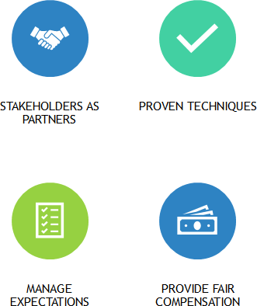
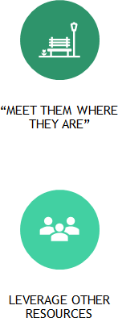

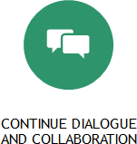

Accessibility

The CMMPO intends to make all public outreach activities fully accessible to all members of the public, regardless of their available transportation alternatives, mobility limitations, or language skills. As an example, providing accessible and ADA-compliant options for people who are deaf, hard of hearing, and/or visually impaired is critical. Further, language translation and interpretation help ensure that qualified individuals are not excluded from participation in, denied the benefits of, or subjected to discrimination under any of its programs, services, or activities as provided by Section 504 of the Rehabilitation Act of 1973 and the ADA. MassDOT recommends the following three best practices to ensure equal access:

Best Practices from the MassDOT Three-Legged Stool of Equal Access

- Title VI Diversity Beyond the usual stakeholders
Virtual platforms and tools make it possible to identify
and connect with new and diverse populations

ADA Accessibility

- Technology
Remove barriers to access
Share accessible information and solicit participation through accessible platforms to promote equal access

Recognize audiences have different internet, devices and broadband capabilities. Plan for phone calls and mailing options to reach populations with non-compatible devices and lack of broadband

CMMPO's Guide to Accessibility in the Public Participation Process

Prior to the Meeting or Outreach Activity
Public meetings should be planned and publicized as early as possible — ideally, at least 21 calendar days, but no less than 14 days in advance.
Meeting notices should include a date by which attendees should request reasonable accommodations
— typically ten days before the meeting.
The meeting notices should also include the process to request reasonable accommodations.
Reasonable accommodations can be made for people with visual or hearing impairments or other disabilities. Provide the contact information of the team members that will take care of all reasonable accommodations' requests.
When a participant requests a reasonable accommodation and/or a language access, respond with an acknowledgement and indicate that the request will be processed in a timely manner.
If you receive a request, you do not know how to fulfill, contact System-Wide Accessibility or the MassDOT Office for Diversity & Civil Rights for technical support. If no third-party service providers are available on the requested date, consider: rescheduling the meeting, holding another meeting session when services are available, working with the requestor to identify other accommodations that may still facilitate their participation.
Log and keep track of the requests and services provided.
Review the MassDOT Accessible Meeting Policy for more information. Available online here: https://www.mass.gov/doc/attachment-14-accessible- meeting-policy/download

Accessible Meeting Locations and Virtual Meetings
If the meeting or event is in-person, make sure that the facility is barrier-free and accessible and listed in the MassDOT Accessible Meeting Location spreadsheet and updated in MassDOT Engage platform. If the facility is not yet included in the list, make sure it complies with all the requirements and add the location to the master list. Use convenient times based on local input and preferences.
Always provide a call-in number for your online meeting. Have a longer public comment period after the meeting if deemed necessary
If the meeting is in-person or hybrid, all public meetings shall be within 1⁄4 mile of an accessible WRTA bus stop or MBTA Commuter Rail station, where feasible.
If public feedback is necessary during a meeting (surveys, polls, weighing different options, etc.), consider making these feedback mechanisms available for a number of days before and/or after the meeting to provide adequate time for responses.

Video Closed-Captioning Provide closed-captioning services within all virtual
meetings and videos.
Create a transcript that can be used as a starting point for closed captioning.
Closed-captioning companies can provide this service for relatively low cost.
Microsoft Teams and YouTube Live include this functionality and can be used for virtual public meetings.
To use, open meeting controls and select More Options > Turn on live captions.
Zoom include two options, including an auto-captioning tool and a live professional captioner.
If using an auto-captioning tool in Zoom, keep the Chat functionality open, if possible, to post clarifications and to allow participants relying on the captions to ask questions in they have difficulties understanding due to auto-caption errors.

Accessible Materials and Formats
Hardcopy handout materials continue to serve an important purpose.
Offer to mail hard copies of the materials being presented for those who are attending virtually.
Check accessibility of all materials, presentations, and documents.
The Microsoft Office and Adobe software suites include accessibility check functionalities to improve your files so they can be better understood by all participants.
In all Microsoft Office programs, including Word and PowerPoint, under the “Review” tab one will find a "Check Accessibility" option, which automatically checks your file for common accessibility issues, indicates areas to review and update, and provides tips on recommended fixes.
Keep text at a minimum: follow accessibility best practices (e.g., provide alternative text for images and charts/tables, use headings, and embedded hyperlinks). Use plain language and clear graphics to convey project information.
Presentations and videos must be closed-captioned before being posted to the web.
Speak clearly, slowly, and directly in the microphone. The Web Content Accessibility Tool can be used to test site’s accessibility and offers recommended fixes.
If requests for additional alternative formats are made in advance of the meeting, these formats must be available at the start of the meeting.
If requests for alternative formats are made at or following the meeting, the alternative format must be provided within seven days of the request.

Translation and Interpretation Services
The Massachusetts Commission for the Deaf and Hard of Hearing (MCDHH) provides accessible communication, education, and advocacy to consumers and private and public entities so that programs, services, and opportunities throughout Massachusetts are fully accessible to persons who are deaf and hard of hearing.
Complete and submit an on-line request for interpreting and CART (Communication Access Realtime Translation) and other accommodation services through the Massachusetts Commission for the Deaf and Hard of Hearing’s (MCDHH) website
Go to http://mass.gov/mcdhh
Interpreter/CART requests are processed online.
Visit https://www.mcdhh.net/request/ to submit your request.
For meetings that are anticipated to last more than 75 minutes, two interpreters must be provided. In most situations, one CART provider is sufficient if the meeting is no longer than three hours.
If the meeting is cancelled or rescheduled, interpreter requests must be cancelled at least 48 hours in advance to avoid being billed for the service. CART providers must be cancelled no later than 72 hours in advance of the event.

Planning Documents

Federal and state regulations require that each MPO document public involvement processes, be proactive and provide complete information, timely public notice, full public access to key decisions, and opportunities for early and continuing involvement. The choice of methods for facilitating participation is left to the discretion of each MPO. All the major CMMPO planning documents and programs require some type of public engagement to achieve the most effective public participation. The major CMMPO planning documents and programs are summarized below.

Long Range Transportation Plan (LRTP)
Updated every 4 years 20-year planning scope
Includes Major Infrastructure Projects
Performance Measures Management Systems

Transportation Improvement Program (TIP)
Updated annually
Program of FHWA and FTA funded projects
Performance Measures Management Systems

Unified Planning Work Program (UPWP)
Updated annually
List of planning activities, tasks and products.
Includes anticipated available funding in the region

Modal Plans and Corridor Profile Studies
Derived from the identified needs and priorities of the region
Identify opportunities for potential initiatives, programs or projects

Long Range Transportation Plan (LRTP)
The Central Massachusetts Long-Range Transportation Plan (LRTP) is the long-range transportation planning document that describes the region's current transportation system and how that system should be maintained and modified over the next 20 plus years. The LRTP needs to be updated every four years by the CMMPO as required by the new national transportation legislation, the Infrastructure Investment and Jobs Act (2021). It addresses each of the major modes of transportation within the Central Massachusetts region and it is considered both a multimodal and an intermodal document. The plan provides an inventory of the major modes, identifies challenges and needs, and provides a series of recommendations for policy, programs and projects.

Project-specific, major transportation improvements need to be reflected in the LRTP to be eligible for federal-aid funding through the region's Transportation Improvement Program (TIP). The most current LRTP, Mobility2040, the Update for 2020, utilized several public participation outreach methods, including a customized approach to stakeholders that are traditionally underrepresented in the decision-making and planning process. Staff used diverse approaches to educate and inform the public about the LRTP process and encourage interested parties to express their views and provide input on transportation issues in the Central Massachusetts planning region.

Transportation Improvement Program (TIP)
The CMMPO Transportation Improvement Program, commonly referred to as the “TIP”, is a federally-required planning document that lists all highway, bridge, transit and intermodal projects in the Central Massachusetts planning region that are programmed to receive federal-aid funding. Projects of regional & statewide significance, non-federal-aid (NFA) or state-funded projects, as well as projects that improve air quality and safety are also included in the TIP document.

Cognizant of limited statewide transportation funding resources, the annual program of projects must demonstrate financial constraint within the federal-aid funding available to each of the state’s MPOs by MassDOT Office of Transportation Planning.

The CMMPO TIP development process is designed to provide early involvement of local legislators, chief local elected officials, stakeholders, individuals and other interested parties in full consideration of the principles of Environmental Justice. This process may also include special meetings, such as community-targeted TIP development meetings and/or information sessions.
Additionally, the TIP document includes a comprehensive overview/summary of the proactive public outreach process used throughout the development of the TIP.

Unified Planning Work Program (UPWP)
The CMMPO Unified Planning Work Program (UPWP) is a task-by-task description of all transportation planning and transportation-related air quality planning activities anticipated within the region during the next upcoming program year. It indicates who will perform the work, anticipated available funding, the schedule for completion and the products that will be produced.

The UPWP is prepared and endorsed annually by the CMMPO prior to the start of the planning program period.

Modal Plans and Corridor Profile Studies
The CMMPO prepares several modal plans including a Freight Planning Progress Report, Regional Bicycle and Pedestrian Plans, Corridor Profile Studies, and and Management System Progress Reports, such as the Congestion Management Process (CMP) for the CMMPO planning region. All these studies and planning documents require customized public participation efforts. These studies and plans provide the opportunity to directly work with stakeholders and develop potential solutions related to the focus. The results from these studies and plans are subsequently included in the next update of the Long-Range Transportation Plan (LRTP). Communities can use the results of these studies to request funds for a transportation project via the Transportation Improvement Program (TIP).
Other organizations can use the results from these studies to
advocate for new legislation, as leverage for other funding Programs, or to procure service enhancements.

Performance Measures

Measuring Meaningful Engagement
Public participation and associated outreach activities are often the most direct contact the public has with the CMMPO. The evaluation of the CMMPO's engagement efforts is key to continue improving and expanding the opportunities the public has to engage with the CMMPO and actively contribute in a meaningful way to the transportation planning process in the region.

Recognizing that public participation is a process in itself, the metrics used to assess the effectiveness of any meaningful engagement should reflect each stage of that process. Accordingly, the metrics included in this section are grouped in three main areas that are geared to different stages of the process, ranging from the initial steps to inform the public to the multiple opportunities for involvement throughout the planning process. The main reference used for this section is from the Texas A&M Transportation Institute: "Performance Measures for Public Participation Methods", published in 2018.

Observe
01
Metrics that quantify the number and type of outreach efforts, the number of participants, among others.
Tracks the response methods, including the response times.
02

Interact
Metrics to assess the delivery, understanding and clarity of the information shared during an interaction with the public. Also, gather information related to the sentiment towards their engagement experience.
03

Incorporate
Quantitative and/or qualitative assessment to determine how the active participation affected or changed the way things are done, the budget was allocated, or the priorities were established and/or changed throughout the transportation planning process.

Observe
Outreach

Number and type of events
Online and in-person events Costs
All associated costs, including hours of labor, print materials, public notice, online engagement platforms, subscriptions, stipends, gift cards, equipment (hardware & software), mileage, etc.
Number and type of documents/media to distribute information to the public Press releases, emails, flyers, letters, newsletters, brochures, videos, etc
Participation

Number of participants at each event Online and in-person events
Number of organizations, communities, agencies represented at each event
Traditional and non-traditional stakeholders, organizations participating for the first time
Response

Number of public comments received
Positive and negative comments, via which mode - social media, email, survey, etc.
Number of website hits
Average response time to submitted comments and inquiries
Demographic information

The purpose is to collect demographic information to know if the outreach and engagement methods are representative of the planning region's population.

Interact
Convenience

Was the event held at a convenient time? Was the event held at a convenient place?
Did you experience any issues accessing the venue (in-person/online)? Did you receive advance notification of the meeting/event/forum?
Where you provided with contact information for individuals that would address any questions you had prior to the meeting?
If you had any questions prior to the meeting, were they adequately addressed?
Participation

Were you given an adequate opportunity to participate?
Do you feel like your input will affect the ultimate decision that is made with regard to the information/projects presented?
Do you feel like your input was accurately captured?
Do you feel like the feedback you received was adequate/timely? Do you feel like your participation made you more involved in the transportation planning process?
Clarity of Information

Was the information beneficial in understanding the process/project? Was the information presented clearly?
Overall Satisfaction

How satisfied are you with the options / solutions presented to you?
Do you feel like what was discussed offered a good solution to the problem?

Incorporate
Public Input

Which public input tools/methods were used throughout the process? Which tools/methods were more successful than others?
Is there a differentiation/preference of tools/methods used by demographic distribution?
Did the agency shared the public input received with the public (transparency)?
Did the agency report back to the public about how their input was used (accountability)?
Are there any changes in the budget allocation as a result of the input received from the public?
Public Engagement

Was demographic data collected from participants at public engagement events to help identify populations who were / were not engaged?
How will this data be used to help guide the planning of future engagement activities?
Did the information gathered from the public engagement process result in modifications to a transportation process, plan or project?
Have public engagement experiences over time affected policies or strategies?
Is there a plan to continue engaging with the participants? Are there potential capacity building opportunities?
Operations

Does the agency have sufficient resources dedicated to public engagement? (i.e., budget, tools, staff, etc.)
What are the lessons learned and what should be improved moving forward?

PAGE INTENTIONALLY LEFT BLANK

